GenericServlet --> init(ServletConfig config)

加载web.xml文件中的servlet 配置区域：DispatcherServlet

HttpServletBean --> init()

ServletConfigPropertyValues --> dispatcher-servlet.xml

FrameworkServlet -->initServletBean()

initWebApplicationContext() --> createWebApplicationContext() --> configureAndRefreshWebApplicationContext() --> configureAndRefreshWebApplicationContext()

AbstractApplicationContext() --> refresh()

getServletContext? getServletConfig?

org.springframework.beans.MutablePropertyValues?

org.springframework.web.servlet.config.AnnotationDrivenBeanDefinitionParser -->parse()?

mvcContentNegotiationManager

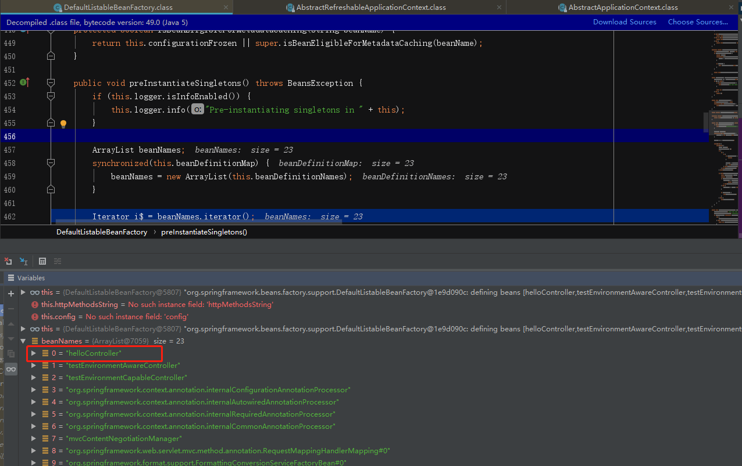

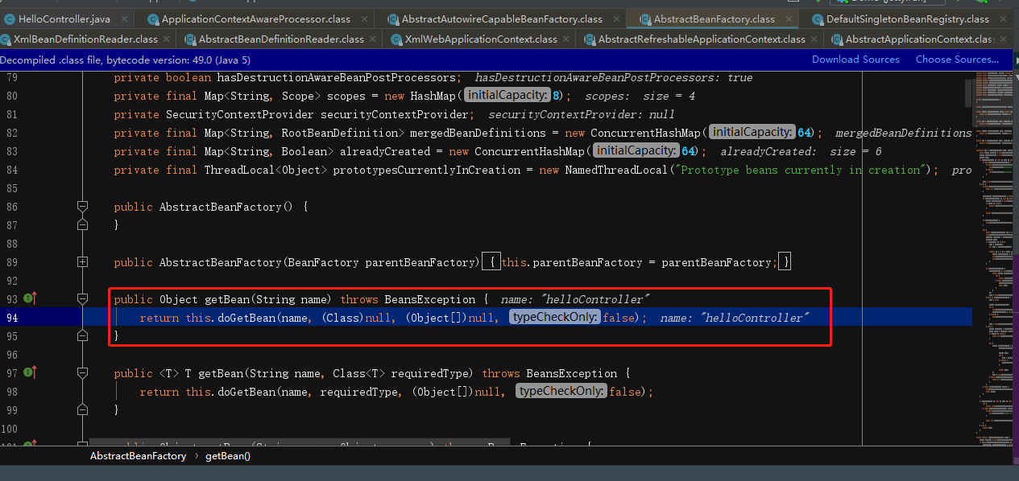

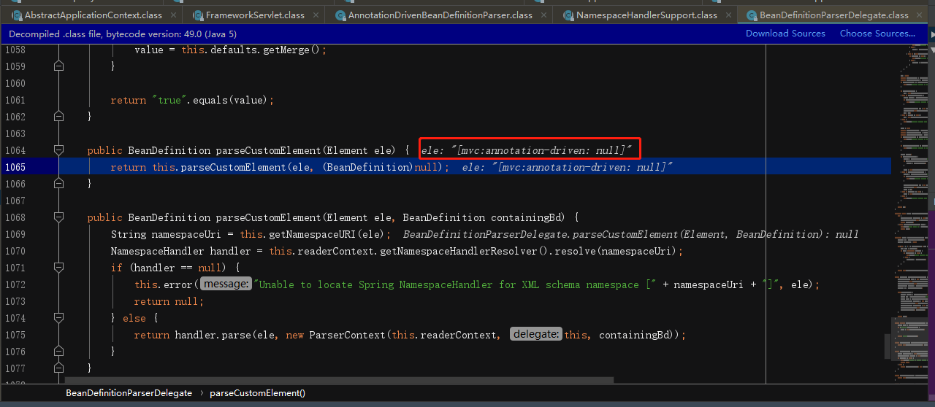

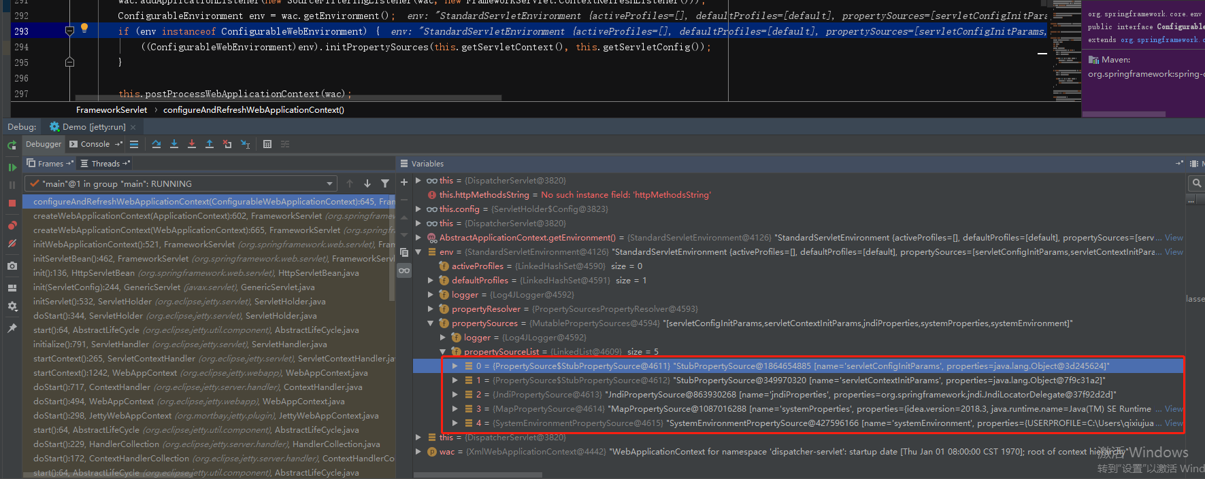

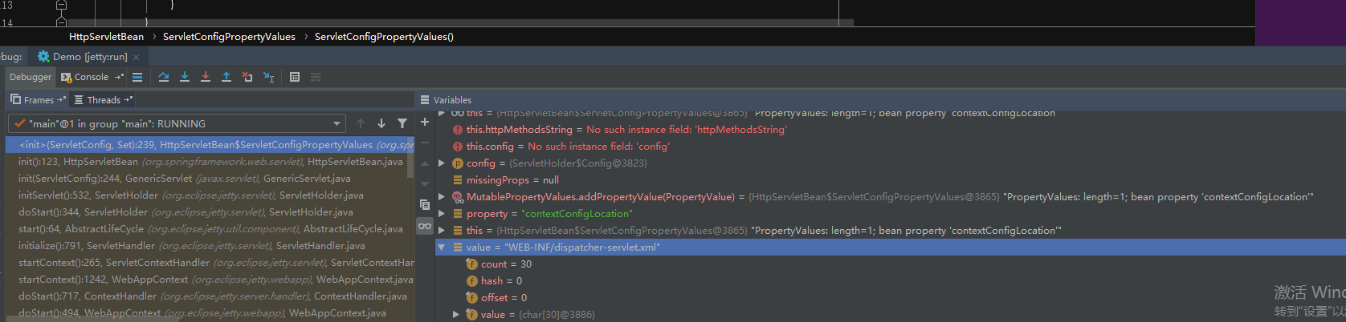

XmlWebApplicationContext